Wireshark Packet Analysis Report

Submitted by : Jaylakshmi B

1. HTTP GET Request (Non-HTTPS)
Screenshot:
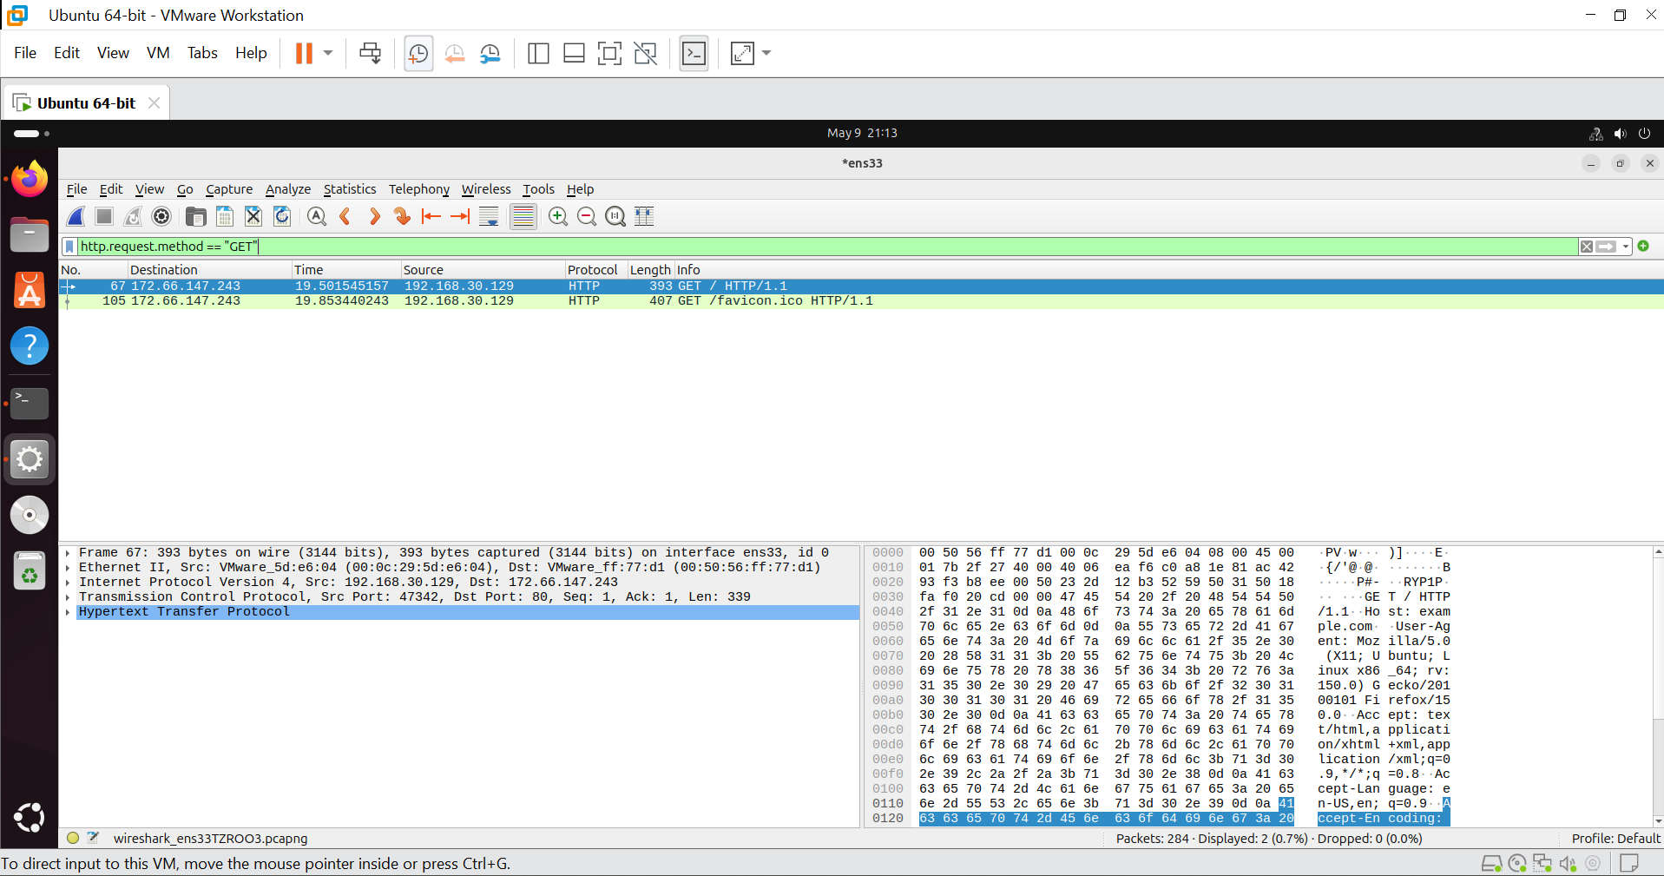
What I did:
- Started a Wireshark capture on interface ens33.
- Visited http://example.com in a web browser.
- Applied display filter http.request.method == "GET".
What the packet reveals:
- The request method is GET, the requested URI is /, and the protocol is HTTP/1.1.
- The Host header shows example.com – this tells the server which website the client wants.
- The User-Agent header reveals the browser and operating system (e.g., Firefox on Ubuntu).
- No encryption – all HTTP headers and payload are transmitted in plain text and can be read directly from the packet capture.

2. DNS Query and Response
Screenshot:
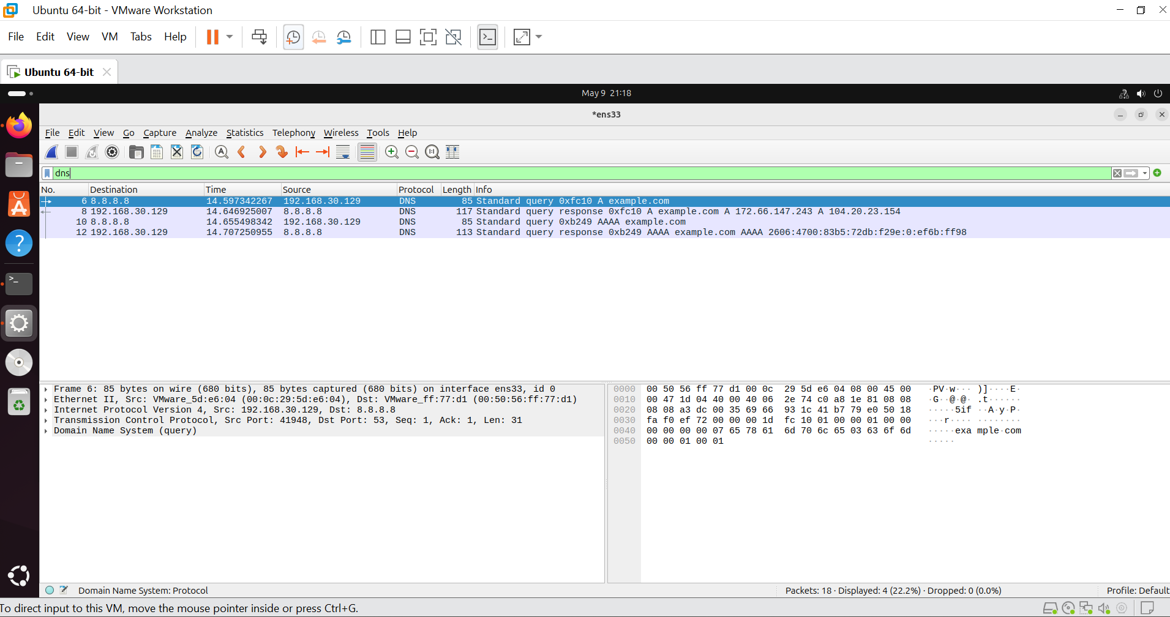
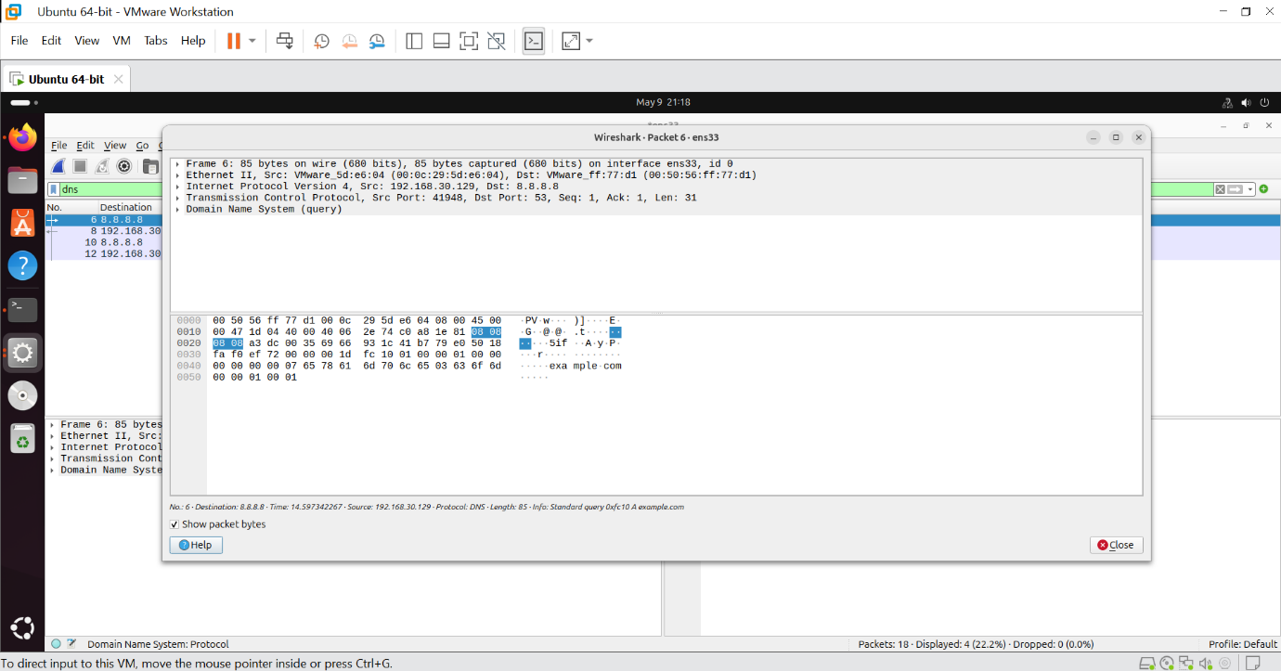
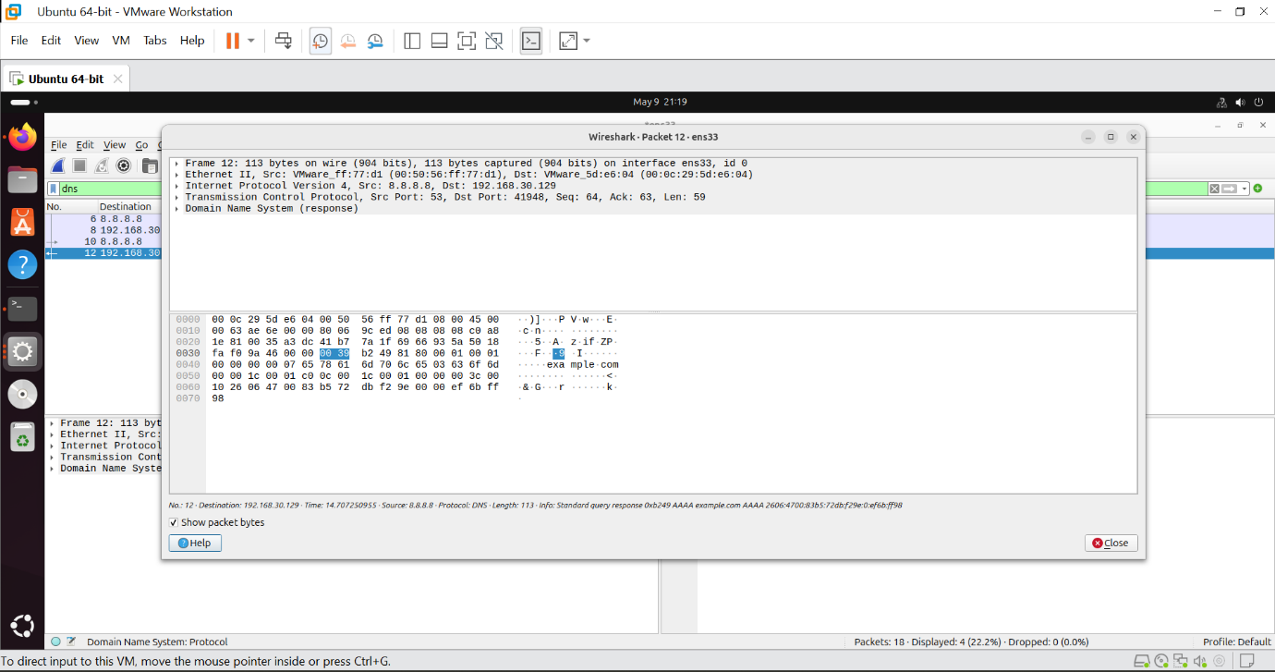

What I did:
- Started a fresh capture.
- Ran nslookup example.com in the terminal.
- Applied filter dns.
What the packets reveal:
- The query packet asks: “What is the IP address of example.com?” (type A record).
- The response packet answers with one or more IP addresses (e.g., 172.66.147.243, 104.20.23.154).
- Both packets share the same Transaction ID (0xfcf10 in my capture), which matches request to response.
- DNS uses UDP port 53 by default.
- This process is essential for converting human-readable domain names into machine-readable IP addresses.

3. TLS Handshake (HTTPS)
Screenshot 1 – Client Hello:
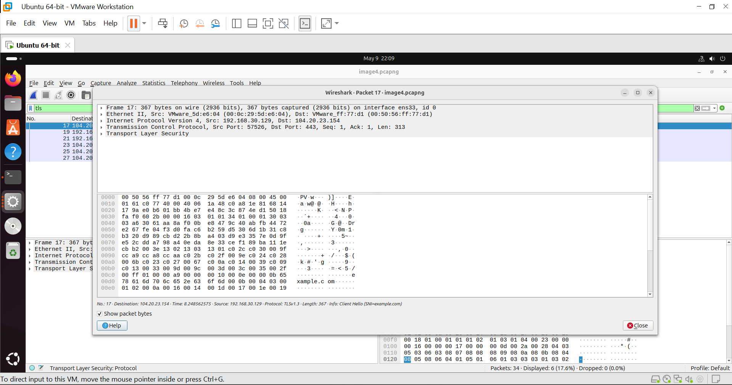
Screenshot 2 – Server Hello:
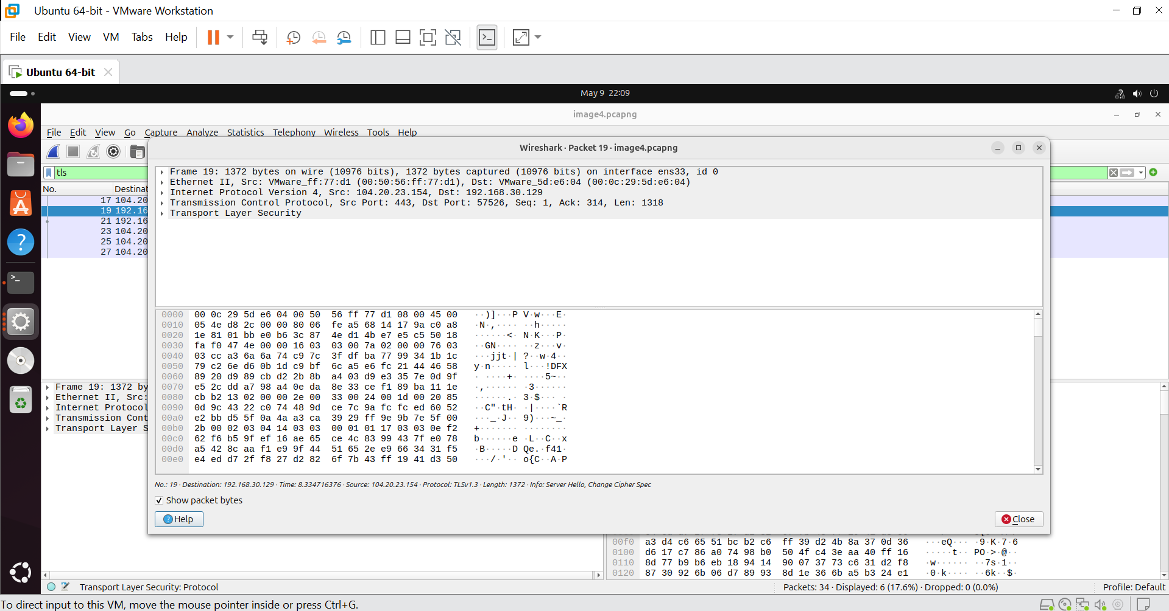

What I did:
- Started a fresh capture.
- Used the command echo | openssl s_client -connect example.com:443 -servername example.com to generate a clean TLS handshake.
- Applied filter tls.
What the packets reveal:
Client Hello:
- The client (my computer) announces the highest TLS version it supports (e.g., TLSv1.3).
- It provides a list of Cipher Suites – encryption algorithms it can use.
- The Server Name Indication (SNI) extension explicitly tells the server that it wants to connect to example.com. (This happens before encryption, so the domain name is visible in the capture.)
Server Hello:
- The server chooses the best cipher suite supported by both parties (e.g., TLS_AES_128_GCM_SHA256).
- The server sends its certificate to authenticate itself.
- After this exchange, all further application data (the actual web page content) is encrypted and cannot be read from the packet capture.

Conclusion
In this project, I successfully captured and analysed three types of network traffic using Wireshark:

Protocol | Visibility | Purpose
HTTP | Plain text | Website browsing without security
DNS | Plain text | Domain name to IP address translation
TLS | Handshake is visible, data is encrypted | Secure website browsing

